APPLICANT NAME:

GRANT APPLICATION FOR
Section 5311(f) Intercity Bus Service
CHECKLIST

The instructions for this application are contained in the Section 5311(f) Intercity Bus Service Application Instructions. PLEASE DO NOT COMPLETE THIS APPLICATION UNTIL YOU FOLLOW THE INSTRUCTIONS IN THE MANUAL. All pages must be completed and all items are required unless otherwise noted. Completed applications must be received in the Public Transportation Section by the date specified in the cover letter accompanying this application packet and manual. Incomplete applications will NOT be considered for funding.

As each item is completed, check the appropriate blank.

- General Agency Information (Page 2)
- Intercity Bus Services (Pages 3 – 4)
- Project Description/Justification
  - Operating Budget Requests (Page 5 - 7)
  - Operating Justification (Page 7)
- Project Notification/Coordination of Services (Page 8)
- Description of Bid Process (Page 9)
- Managerial Capabilities (Pages 9-12)
  - Three years of financial statements (Page 9)
  - Copies of financial data for current payment of federal and state taxes (Page 11)
  - Copy of insurance policy or letter from insurance agency (Page 11)
- Planning Requirements (Page 13)
- Title VI Compliance & Miscellaneous Requirements (Page 13 -14)
- Project Assurances (Pages 14 -19)
- Appendix A (Required Documentation) (Page 24)
  - Certified copy of Public Notice
  - Copies of all responses received
  - Copies of Coordination agreements
  - Copies of MPO letter regarding Coordinated Public Transit-Human Service Plan and
response letter
  - Authorizing resolution (1 Original)
  - 5333(B) Labor Warranty requirements (Chart) (Page 25)
  - Maps of current service areas with routes marked
  - Fare Schedule
  - Service Schedule
  - Service Policy
  - Substance Abuse Prevention Program Policy
  - Drug and Alcohol Part 655 Certification
  - Bid proposal of selected contractor
  - In-kind match documentation

APPLICANT NAME:

GRANT APPLICATION FOR SECTION 5311(f) INTERCITY BUS SERVICE
I. GENERAL AGENCY INFORMATION
APPLICANT ORGANIZATION (PUBLIC BODY) |  |  |  |  |  |  |  |  | DATE OF APPLICATION
ADDRESS, CITY, STATE AND ZIP CODE |  |  |  |  |  |  |  |  | FEDERAL ID#
CONTACT PERSON, TITLE |  |  |  |  |  |  |  |  | PHONE NO.
EMAIL |  |  |  |  |  |  |  |  | FAX NO.
DESIGNEE ORGANIZATION (if different from Applicant) |  |  |  |  |  |  |  |  | FEDERAL ID#
ADDRESS, CITY, STATE AND ZIP CODE |  |  |  |  |  |  |  |  | PHONE NO.
CONTACT PERSON, TITLE |  |  |  |  |  |  |  |  | FAX NO.
EMAIL |  |  |  |  |  |  |  |  | DUNNS#
TOTAL FTA INTERCITY BUS FUNDING |  |  |  | AWARDED |  |  | REQUESTED
 |  |  |  | 07/01/22 – 06/30/24 |  |  | 07/01/24 – 06/30/26
Operating (Federal Share only) 50%
IF REQUEST IS FULLY FUNDED, TRANSPORTATION SERVICE WILL BE:
Continued at Current Level
Expanded (Please Describe)
New Services (Please Describe)
DESCRIPTION OF:
- SERVICE AREA POPULATION |  |  |  |  | - SYSTEM USERS
 | % Elderly/Disabled |  | % Minority* |  |  | % Elderly/Disabled |  |  |  | % General Population
*Minority = African American, Hispanic, Asian, Native American |  |  |  |  | = 100% (Above should total 100%)  ________% Minority* (What % of Total Users is Minority)
 |  |  |  |  | APPLICANT NAME: |  | ___________________________
II. INTERCITY BUS SERVICE
A. Provide the information requested for each item listed below.
1) What are the town or city beginning and ending points for the service?
2) What are the rural and urban intermediate stops along the route? Please list them.
3) What is the total of one-way route miles?
4) What is the number of Louisiana one-way route miles?
5) What will the annual days of service be?
6) What will be the annual Louisiana-segment roundtrip route miles?
7) What is the annual percentage of minority population served in # 6?

RIDERSHIP DATA | ANNUAL AND ESTIMATED RIDERSHIP for  July 1 – June 30 for each SFY
RIDERSHIP DATA | 2023  ACTUAL | 2024  PLANNED | 2025  ESTIMATED | 2026 ESTIMATED
Total Annual Ridership on Full Route
Total Annual Ridership on Louisiana Segment
Total Annual Ridership at rural stops - non-urbanized, less than 50,000 in LA
*Please indicate N/A if ridership information is not available.

B. Description of fare policy: Also include in Appendix A a copy of the official fare schedule which you post publicly. There are NO “free rides”. Some program or local funds must cover the cost of every ride.

APPLICANT NAME:

II. INTERCITY BUS SERVICE (Continued)

C. CURRENT VEHICLE INVENTORY

Print a fleet inventory. In the LEFT margin, indicate which, if any, vehicles are spares/used as BACKUP. Place a "B" next to any backup vehicles. In the RIGHT margin, indicate the GENERAL CONDITION of each vehicle, as Excellent, Good, Fair or Poor.

ATTACH COPY OF CURRENT INSURANCE FOR ALL VEHICLES.

DOTD USE ONLY | VIN  (Vehicle  Identification #) | MODEL YEAR | CURRENT ODOMETER  READING |  | SEATING CAPACITY | HANDICAP ACCESS  YES/NO |  | BACKUP VEHICLE YES/NO | GENERAL CONDITION  E, G, F, P
 |  |  |  | APPLICANT NAME:

- PROJECT DESCRIPTION/JUSTIFICATION

A. OPERATING ASSISTANCE PROJECT BUDGET (7/1/24 - 6/30/26)

Please refer to pages 6-15 of the Application Procedures Manual for complete instructions.

1. | Eligible Operating Expenses (USE WORKSHEET A, |  |  |  |  | (1)
 | NEXT PAGE, TO ITEMIZE)
2. | Fare box:
 |  | Cash Fares | $ |  | (2)

3. | Net Project Cost | (3)
 | (Line 1 less Line 2)
4. | FTA Intercity Bus Funds Requested | (4)
 | (Maximum 50% of Line 3)
5. | Minimum Net Expenses (Line 3 less Line 4) | (5)
6. | Funds to cover remaining minimum 50% of | (6)
 | Net Expenses (Local Share*):

7. | Federal Funds: (List total amounts from all sources of revenue applicable to costs)
Amount
$
$
$

Non-Federal/Local Funds:
Amount
$
$
$

Inkind**:
$
$
$

(7)
TOTAL LOCAL SHARE:

* At least half of the local share for net operating cost must be provided in cash or cash equivalent from sources other than federal funds.

** Attach proper documentation to establish the value of direct contribution of services. (See page 5 of Application Manual)

APPLICANT NAME:

- PROJECT DESCRIPTION/JUSTIFICATION (Continued)

B. OPERATING ASSISTANCE PROJECT BUDGET (7/1/24 - 6/30/26)

WORKSHEET A

ADMINISTRATIVE EXPENSES

Salary/Wages--Administration

Fringe Benefits--Administration

Subtotal Administration--Salary & Fringe

Non-Vehicle Insurance

Facilities--Rent

Equipment--Lease

Utilities

Postage

Telephone

Office Supplies

Marketing/Advertising

Substance Abuse Testing, etc.

Professional Services

Travel

Training

Audit

HIV/First Aid Kits

Other (List)

Subtotal Administrative--Other

OPERATING EXPENSES

Salary/Wages--Drivers

Salary/Wages--Dispatcher

Salary/Wages--Mechanic

Fringe Benefits--Drivers

Fringe Benefits--Dispatcher

Fringe Benefits--Mechanic

Vehicle Insurance

Fuel & Oil

Replacement Parts (Non-Capital)

Maintenance & Repairs

Licensing & Registration

Purchased Transportation Services

Other (List)

Subtotal Operating Expense

TOTAL TRANSPORTATION EXPENSES

APPLICANT NAME:

- PROJECT DESCRIPTION/JUSTIFICATION (Continued)

C. ITEMS 1 and 2 MUST BE COMPLETED FOR OPERATING ASSISTANCE PROJECTS.
JUSTIFY BENEFIT AND NECESSITY.

- Describe how this project benefits and supports Intercity Bus service to and from
non-urbanized areas.

- Provide a brief justification why this project should be funded. Clearly explain
what type of environment you are operating in, what type of transportation service you are
providing and why the funding request you are making is justified.

APPLICANT NAME:

IV. PROJECT NOTIFICATION/COORDINATION OF SERVICES

The process to be followed in notifying other transportation providers of your request for an Intercity Bus grant is fully explained in your application manual on Pages 14-24.

- In appendix A, provide a Certified newspaper copy of your Public Notice. (A public notice is required if
the applicant (public body) will provide the transit service.)

- In appendix A, provide a copy of the Solicitation and Bid proposal of selected contractor if applicant
intends to bid the service.

C. Describe any public and/or private sector comments or objections received in response to your efforts in A-B above and explain how these were reviewed and/or resolved. (Refer to Pages 16-17 of the Application Manual for complete instructions on handling objections.)

D. MAP-21 requires projects selected for funding be derived from a coordinated public transit-human services transportation plan. Applicants must submit a copy of their proposal to the respective MPO for inclusion in their plan. A copy of your initial letter to the MPO along with the response letter from the MPO stating that this project, if funded, will be included in the coordinated public transit-human service transportation plan must be submitted with your application. Please refer to page 18 for a sample letter and page 2 of the Application Procedures Manual for the addresses of these organizations.

APPLICANT NAME:

E. Attach as Appendix A to your application the following:

1. Certified newspaper copy of your public notice/copy of bid solicitation (clip notice only).
2. Copies of all responses received
3. Copies of any coordination agreements.
4. Copies of initial letter to the MPO regarding Coordinated Public Transit-Human Services
Transportation Plan and the response letter.

V. DESCRIPTION OF BID PROCESS

The bid process is required if the applicant (public body) will contract the service. The solicitation must include all federal clauses required to receive funding. Required federal clauses can be found in Appendix B pages 1-15 of the Intercity Bus Application Manual.

A. Describe the bid process and procurement procedures used in selecting the successful bidder.
Attach a copy of the solicitation used and a copy of the successful bidder proposal.

VI. MANAGERIAL CAPABILITES

A. FINANCIAL CAPABILITY

The following must be submitted with your application:

- Three years of financial statements illustrating the Contractor’s ability to sustain the service and maintain vehicles. Financial statements include: balance sheet, statement of revenues and expenses, and cash flow statement. In the event that the contractor has not been in business for three years, financial statements covering the period of operation is acceptable.
APPLICANT NAME: ___________________________

VI. MANAGERIAL CAPABILITES (Continued)

- Financial data indicating that the Contractor is current with payment of federal and state taxes
- Proof that the Contractor can secure and maintain the liability insurance needed to operate this service. This can be accomplished by providing a copy of the Contractor’s insurance policy or a letter from an insurance agency stating that it will issue insurance to the contractor upon application.

A Contractor in bankruptcy or court approved reorganization is not eligible for a minimum of two years and until the company can exhibit financial stability and capability to meet the terms and conditions of this program. A Contractor that has operated service or equipment under contractual agreement with the Department must have done so with no penalties imposed. The Contractor is ineligible for two years from the date of any such penalty being imposed.

- MANAGEMENT

For each of the following items, check the statement that best applies to your organization.

1. FUND AVAILABILITY

The non-FTA funds required by your organization to operate your transportation system over the next five years are:

 | a. | a certainty because of the stability of the income source.
 | b. | reasonably secure but because several of the sources are subject to variation,
 |  | the revenues to cover operational expenses are not guaranteed.
 | c. | fairly uncertain because all funding sources are not reliable or guaranteed.

2. EXPERIENCE

How many years of experience does your agency have in operating public transportation systems.

 | a. no experience |  | d. between 5 - 10
 | b. less than 1 year |  | e. between 10 - 15
 | c. between 1 - 5 |  | f. more than 15

3. MAINTENANCE PROGRAM

Which of the following best describes your maintenance program?

 | a. | a documented preventative maintenance program is being utilized.
 | b. | an individual is assigned responsibility for insuring that each vehicle is properly
 |  | maintained.
 | c. | drivers have primary responsibility for overseeing the maintenance of their vehicle(s).
 | d. | none of the above; we do the following:

APPLICANT NAME:___________________________

VI. MANAGERIAL CAPABILITES (Continued)

4. Driver Selection

When selecting drivers does your agency . . .

 | a. | check driving records?
 | b. | require a physical
 | c. | other; specify:

5. Training

What training courses have been provided to your employees during the last year?

 | a. | CPR
 | b. | an approved Red Cross First Aid class
 | c. | Passenger Assistance Techniques) and/or PASS (Passenger Assistance,
 |  | Sensitivity and Safety)
 | d. | other; specify:

6. Describe activities routinely undertaken to monitor, evaluate, and improve your transportation
program:

APPLICANT NAME: _________________________

VI. MANAGERIAL CAPABILITES (Continued)

7. List key personnel (names and titles) along with assigned responsibilities for transportation-
related activities. Also provide a copy of your organizational chart and a list of your board
members and advisory groups. Attach additional pages if necessary.

8. Describe all marketing plan and budget to publicize the transportation services.

APPLICANT NAME:_____________________________

VII. PLANNING REQUIREMENTS

Please check the applicable blank:

 | A. | If your project is within the current planning/study area boundaries of a Metropolitan Planning
 |  | Organization (MPO) located in Alexandria, Baton Rouge, Houma, Lafayette, Lake Charles, Monroe, New Orleans, or Shreveport, your request for this operating assistance must be approved by the MPO for the area and included in its Transportation Improvement Plan (TIP). Please refer to Page 21 of the Application Manual for the addresses of these organizations. Attach to this page a copy of your initial letter to the MPO along with a letter of reply from the MPO stating that this project will be included in the TIP.

 | B. | This project is not within an MPO's current planning/study area boundaries.

VIII. SPECIAL PROVISIONS REGARDING TITLE VI COMPLIANCE AND MISCELLANEOUS REQUIREMENTS

Items 1-3 below concerns pending applications for other Federal aid, discrimination lawsuits and civil rights compliance reviews. If any do not apply, write "N/A".

- Describe all pending applications for Federal financial assistance whether transit-related or otherwise, and all financial assistance currently provided by other Federal agencies. Include name of contract or program (ex., Title IIIB, CSBG, etc.) and amount.

- If applicable, provide a concise description of any lawsuits or complaints alleging discrimination on the basis of race, color, creed, or national origin, sex, age or disability filed against the applicant or recipient within the past year. State the status or outcome of each such complaint or lawsuit.
APPLICANT NAME:________________________________

VIII. SPECIAL PROVISIONS REGARDING TITLE VI COMPLIANCE AND MISCELLANEOUS REQUIREMENTS (Continued)

- Summarize all civil rights compliance review actions which may have been conducted in the last three years.

IX. LA DOTD & FTA PROJECT ASSURANCES AND CERTIFICATIONS

Carefully read the following legally binding project assurances and certifications reflected on pages 25 through 29. The authorized representative is required to make these assurances on behalf of the applicant by signing pages 20-22.

CATEGORY I - CERTIFICATIONS AND ASSURANCES TO LA DOTD FOR THE
NONURBANIZED AREA FORMULA PROGRAM

The applicant administering on behalf of the state the Formula Grants for Rural Areas Program authorized by 49 U.S.C. 5311 certifies and assures that the following requirements and conditions will be fulfilled:

The applicant will have the necessary legal, financial, and managerial capability to apply for, receive, and disburse federal assistance authorized for 49 U.S.C. 5311, and to implement and manage the project.

The applicant assures that sufficient non-federal funds have been or will be committed to provide the required local share.

The applicant has, or will have by the time of delivery, sufficient funds to operate and maintain the vehicles and equipment purchased with federal assistance awarded for this project.

The applicant assures that before the state issues a formal approval of a project, that its Non-urbanized Area Formula Program has been included in the Statewide Transportation Improvement Program as required by 23 U.S.C. 135 to the extent applicable projects are included in a metropolitan Transportation Improvement Program, and it has obtained from the prospective sub-recipient of assistance a certification that an opportunity for a public hearing has been provided.

The applicant assures that it has to the maximum extent feasible, coordinated with other transportation providers and users, including social service agencies authorized to purchase transit service.

The applicant assures that it is in compliance with all applicable civil rights requirements, and has signed the Nondiscrimination Assurance (Category II).

APPLICANT NAME:___________________________

The applicant assures that it will comply will all applicable requirements of U.S. DOT regulations on participation of disadvantaged business enterprise in U.S. DOT programs.

The applicant will comply with all existing federal requirements regarding transportation of elderly persons and persons with disabilities. The applicant has provided to the State an Assurance of Nondiscrimination on the Basis of Disability, as set forth in the Certifications and Assurances required of each Applicant for FTA assistance. If non-accessible vehicles are being purchased for use by a public entity in demand responsive service for the general public, the applicant will provide a "Certification of Equivalent Service," which states that the public entity's demand responsive service offered to person with disabilities, including persons who use wheelchairs, is equivalent to the level and quality of service the public entity offers to persons without disabilities. (See Category II., Certifications and Assurances Required of each Applicant.)

This "Certification of Equivalent Service" must also state that the public entity's demand responsive service, when viewed in its entirety, is provided in the most integrated setting feasible and has equivalent: (1) response time, (2) fares, (3) geographic service area, (4) hours and days of service, (5) restrictions or restraints on trip purpose, (6) availability of information and reservation capability, and (7) constraints on capacity of service availability. (See Category IV Certifications Required For FTA Assistance to an applicant for its Demand Response Service)

- The applicant has complied with the transit employee protective provisions of 49 USC 5333(b), by one of the following actions: (1) signing the Special Warranty for the non-urbanized Area Formula Grant for Rural Areas Program, (2) agreeing to alternative comparable arrangements approved by the Department of Labor (DOL), or (3) obtaining a waiver from DOL; and the applicant has certified the sub-recipient's compliance to DOL.

- The applicant certifies to the state that it will comply with 49 CFR part 604 in the provision of any charter service provided with equipment acquired, maintained, or operated with FTA assistance, and will also comply with applicable provisions of 49 CFR 605 pertaining to school transportation operations. (See Category V, "Charter Service Agreement," and Category VI," School Transportation Agreement.")

- Unless otherwise noted, each of the applicant's projects qualifies for a categorical exclusion and does not require further environmental approvals, as described in the joint FHWA/FTA regulations,

- "Environmental Impact and Related Procedures," at 23 CFR 771.117(c). The state certifies that financial assistance will not be provided for any project that does not qualify for a categorical exclusion described in 23 CFR 771.117© until FTA has made the required environmental finding. The state further certifies that no financial assistance will be provided for a project requiring a conformity finding in accordance with the Environmental Protection Agency's Clean Air Conformity regulations at 40 CFR parts 51 and 93, until FTA makes the required conformity finding.

- The applicant has submitted all certifications and assurance currently required, including but not limited to: a certification that its procurement and procurement system will comply with all applicable requirements imposed by Federal laws, executive orders, or regulations and the requirements of FTA Circular 4220.1F, last revised 03/18/13 "Third Party Contracting Requirements," and other implementing requirements FTA may issue, a certification that its project provides for the participation of private mass transportation companies to the maximum extent feasible; a certification it has paid or will pay just compensation under state or local law to each private mass

APPLICANT NAME:___________________________

transportation company for its franchise or property acquired under the project; a non-procurement suspension and debarment certification; a lobbying certification for each application exceeding
$100,000; and if required by FTA, an anti-drug program certification and an alcohol testing certification. Certifications and assurances applicable to and submitted by the sub-recipient should be substantially similar to the test of parallel certifications and assurances text of Categories I-X of this document, but modified as necessary to accommodate the applicant's circumstances.

- The applicant will enter into an FTA-approved written agreement with any subrecipient stating the terms and conditions of assistance by which the project will be undertaken and completed.

- The applicant recognizes DOTD's and FTA's authority to conduct audits to verify compliance with the foregoing requirements and stipulations.

CATEGORY II - NONDISCRIMINATION ASSURANCE

As required by 49 U.S.C. 5332, Title VI of the Civil Rights Act of 1964, as amended, 42 U.S.C. 2000d, and U.S. DOT regulations, "Nondiscrimination in Federally-Assisted Programs of the Department of Transportation - Effectuation of Title VI of the Civil Rights Act, "49 CFR part 21 at 21.7, the applicant assures that it will comply with all requirements of 49 CFR part 21; FTA Circular 4702.1, "Title VI Program Guidelines for Federal Transit Administration Recipients", and other applicable directives, so that no person in the United States, on the basis of race, color, national origin, creed, sex or age will be excluded from participation, be denied the benefits of, or otherwise be subjected to discrimination in any program or activity (particularly in the level and quality of transportation services and transportation-related benefits) for which the applicant receives federal assistance awarded by the U.S. DOT or FTA as follows:

- The applicant assures that each project will be conducted, property acquisitions will be undertaken, and project facilities will be operated in accordance with all applicable requirements of 49 U.S.C. 5332 and 49 CFR part 21, and understands that this assurance extends to its entire facility and to facilities operated in connection with the project.

- The applicant assures that it will take appropriate action to ensure that any transferee receiving property financed with federal assistance derived from FTA will comply with the applicable requirement of 49 U.S.C. 5332 and 49 CFR part 21.

- The applicant assures that it will promptly take the necessary actions to effectuate this assurance, including notifying the public that complaints of discrimination in the provision of transportation related services or benefits may be filed with U.S. DOT or FTA. Upon request by the U.S.DOT or FTA, the applicant assures that it will submit the required information pertaining to its compliance with these requirements.

- The applicant assures that it will make any changes in its 49 CFR part 21 and 49 U.S.C. 5332, and Title VI implementing procedures as U.S. DOT or FTA may request.

- As required by 49 CFR 21.7(a)(2), the applicant will include appropriate clauses in each third party contract or sub-agreement to impose the requirements of 49 CFR part 21 and 49 U.S.C. 5332, and include appropriate provisions imposing those requirements in deeds and instruments recording the transfer of real property, structures, improvements.

APPLICANT NAME:___________________________

CATEGORY III - ASSURANCE OF NONDISCRIMINATION ON THE BASIS OF DISABILITY

As required by U.S. DOT regulations, "Nondiscrimination on the Basis of Handicap in Programs and Activities Receiving or Benefiting from Federal Financial Assistance," at 49 CFR part 27, implementing the Rehabilitation Act of 1973, as amended, and the Americans with Disabilities Act of 1990, as amended, the Applicant assures that, as a condition to the approval or extension of any Federal assistance awarded by FTA to construct any facility, obtain any rolling stock or other equipment, undertake studies, conduct research, or to participate in or obtain any benefit from any program administered by FTA, no otherwise qualified person with a disability shall be, solely by reason of that disability, excluded from participation in, denied the benefit of, or otherwise subjected to discrimination in any program or activity receiving or benefiting from federal assistance administered by the FTA or any entity with U.S. DOT. The applicant assures that project implementation and operations so assisted will comply with all applicable requirements of U.S. DOT regulations implementing the Rehabilitation Act of 1973, as amended, and the

Americans with Disabilities Act of 1990, as amended, at 49 CFR parts 27, 37, and 38, and any applicable regulations and directives issued by other federal departments or agencies.

CATEGORY IV - CERTIFICATION REQUIRED FOR FTA ASSISTANCE TO AN APPLICANT
FOR ITS DEMAND RESPONSIVE SERVICE

As required by U.S. DOT regulations, "Transportation Services for Individuals with Disabilities (ADA)," at 49 CFR 37.77, the applicant certifies that its demand responsive service offered to persons with disabilities, including persons who use wheelchairs, is equivalent to the level and quality of service offered to persons without disabilities. When viewed in its entirety, its service for persons with disabilities is provided in the most integrated setting feasible and is equivalent with respect to: (1) response time, (2) fares, (3) geographic service area, (4) hours and days of the service, (5) restrictions on trip purpose, (6) availability of information and reservation capability, and (7) constraints on capacity or service availability.

CATEGORY V - CHARTER SERVICE AGREEMENT

- As required by 49 U.S.C. 5323(d) and FTA regulations, "Charter Service," at 49 CFR 604.7, the applicant agrees that it and its sub-recipients will: (1) provide charter service that uses equipment acquired, operated or maintained with FTA assistance authorized for 49 U.S.C. 5307, 5309, or 5311 or Title 23 U.S.C., only to the extent that there are no private charter service operators willing and able to provide the charter service that it or its subrecipients desire to provide, unless one or more of the exceptions in 49 CFR 604.9 applies, and (2) comply with the provisions of 49 CFR part 604 before they provide any charter service using equipment acquired, operated or maintained with Federal assistance authorized for the above statutes.

- The Applicant understands that the requirements of 49 CFR part 604 will apply to any charter service provided, the definitions in 49 CFR part 604 apply to this agreement, and violation of this agreement may require corrective measures and the imposition of penalties, including debarment from the receipt of further Federal assistance for transportation.

APPLICANT NAME:___________________________

CATEGORY VI - SCHOOL TRANSPORTATION AGREEMENT

- As required by 49 U.S.C. 5323(f) and FTA regulations, "School Bus Operations," at 49 CFR 605.14, the applicant agrees that it and all its recipients will (1) engage in school transportation operations in competition with private school transportation operators only to the extent permitted by an exception provided by 49 U.S.C. 5323(f), and implementing regulations, and (2) comply with the requirements of 49 CFR part 605 before providing any school transportation using equipment or facilities acquired with federal assistance authorized by 49 U.S.C. chapter 53 or Title 23 U.S.C. awarded by FTA for transportation projects.

- The applicant understands that the requirement of 49 CFR part 605 will apply to any school transportation it provided, the definitions of 49 CFR part 605 apply to this school transportation agreement, and a violation of this agreement may require corrective measures and the imposition of penalties, including debarment from the receipt of further federal assistance for transportation.

CATEGORY VII - PROCUREMENT COMPLIANCE

The Authorized Representative signs to assure that the applicant and its subrecipients will comply with 49 U.S.C. 5323 (d) and FTA "Charter Service" regulations at 49 CFR 604, and understands the penalties for violation of same.

CATEGORY VIII - LOBBYING CERTIFICATION

As required by U.S. DOT regulations, "New Restrictions on Lobbying," at 49 CFR 20.110, the Applicant certifies that for each application for Federal assistance exceeding $100,000: (1) No Federal appropriated funds have been or will be paid, by or on behalf of the Applicant, to any person for influencing or attempting to influence an officer or employee of any agency, a Member of Congress or the State Legislature, an officer or employee of Congress or the State Legislature, or an employee of a Member of Congress or the State Legislature pertaining to the award of any Federal assistance, or the extension, continuation, renewal, amendment, or modification of any Federal assistance agreement; and (2) If any funds other than Federal appropriated funds have been or will be paid to any person for influencing or attempting to influence an officer
or employee of any agency, a Member of Congress or the State Legislature, an officer or employee of Congress or the State Legislature, or an employee of a Member of Congress or the State Legislature in connection with any application to FTA for Federal assistance, the Applicant assures that it will complete and submit Standard Form-LLL, "Disclosure Form to Report Lobbying," including the information as permitted by 31 U.S.C. 1352.

The Applicant understands that this certification is a material representation of fact upon which reliance is placed and that submission of this certification is a prerequisite for providing Federal assistance for a transaction covered by 31 U.S.C. 1352. The Applicant also understands that any person who fails to file a required certification shall be subject to a civil penalty of not less than $10,000 and not more than $100,000 for each such failure.

APPLICANT NAME:___________________________

CATEGORY IX - EFFECTS ON PRIVATE MASS TRANSPORTATION COMPANIES

As required by 49 U.S.C. 5323(a)(1), the Applicant certifies that:

It has provided for the participation of private mass transportation companies to the maximum extent feasible.

CATEGORY X - DEBARMENT CERTIFICATION

CERTIFICATION REGARDING DEBARMENT, SUSPENSION, AND OTHER RESPONSIBILITY MATTERS - PRIMARY COVERED TRANSACTION

The Applicant certifies to the best of its knowledge and belief, that it and its principals/subrecipients:

- Are not presently debarred, suspended, proposed for debarment, declared ineligible, or voluntarily excluded from covered transactions by any Federal debarment or agency;

- Have not within a three-year period preceding this proposal been convicted of or had a civil judgment rendered against them for commission of fraud or a criminal offense in connection with obtaining, attempting to obtain, or performing a public (Federal, State or local) transaction or contract under a public transaction; violation of Federal or State antitrust statutes or commission of embezzlement, theft, forgery, bribery, falsification or destruction of records, making false statements, or receiving stolen property;

- Are not presently indicted for or otherwise criminally or civilly charged by a governmental entity (Federal, State or local) with commission of any of the offenses enumerated in paragraph (2) of this certification; and

- Have not within a three-year period preceding this application/proposal had one or more public transaction (Federal, State or local) terminated for cause or default.

Where the Applicant is unable to certify to any of the statements in this certification, such participation shall attach an explanation to this proposal.

THE APPLICANT CERTIFIES OR AFFIRMS THE TRUTHFULNESS AND ACCURACY OF THE CONTENTS OF THE STATEMENTS SUBMITTED ON OR WITH THIS CERTIFICATION AND UNDERSTANDS THAT THE PROVISIONS OF 31 U.S.C. §§ 3801 ET SEQ. ARE APPLICABLE THERETO.

APPLICANT NAME:

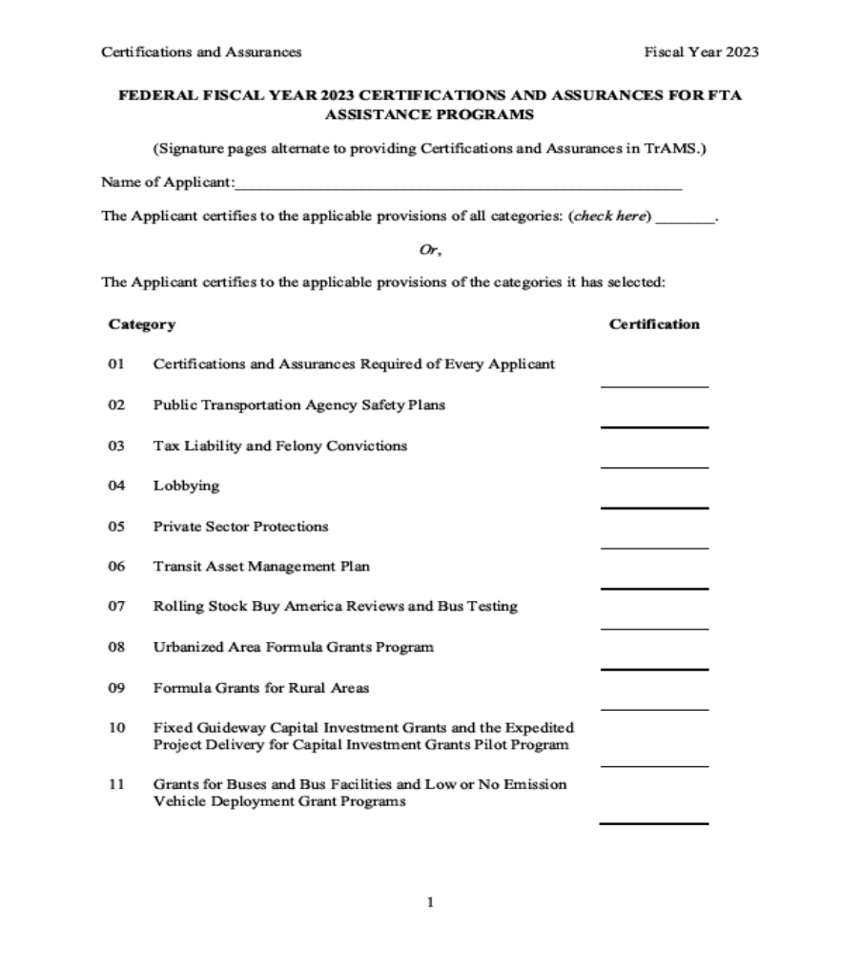
APPLICANT NAME:

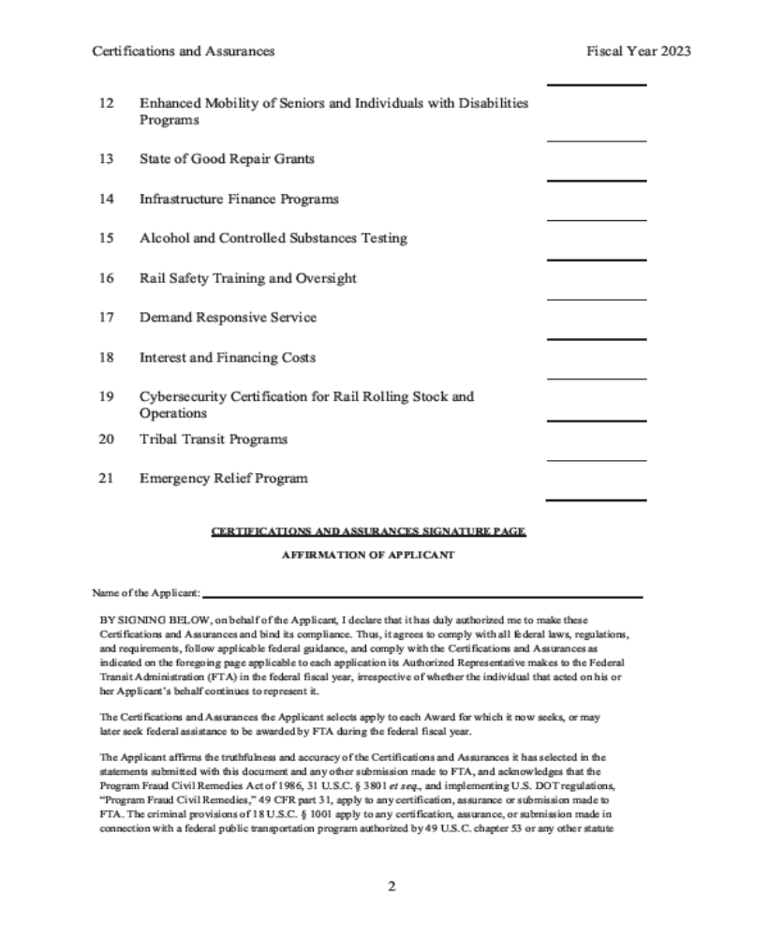

APPLICANT NAME:

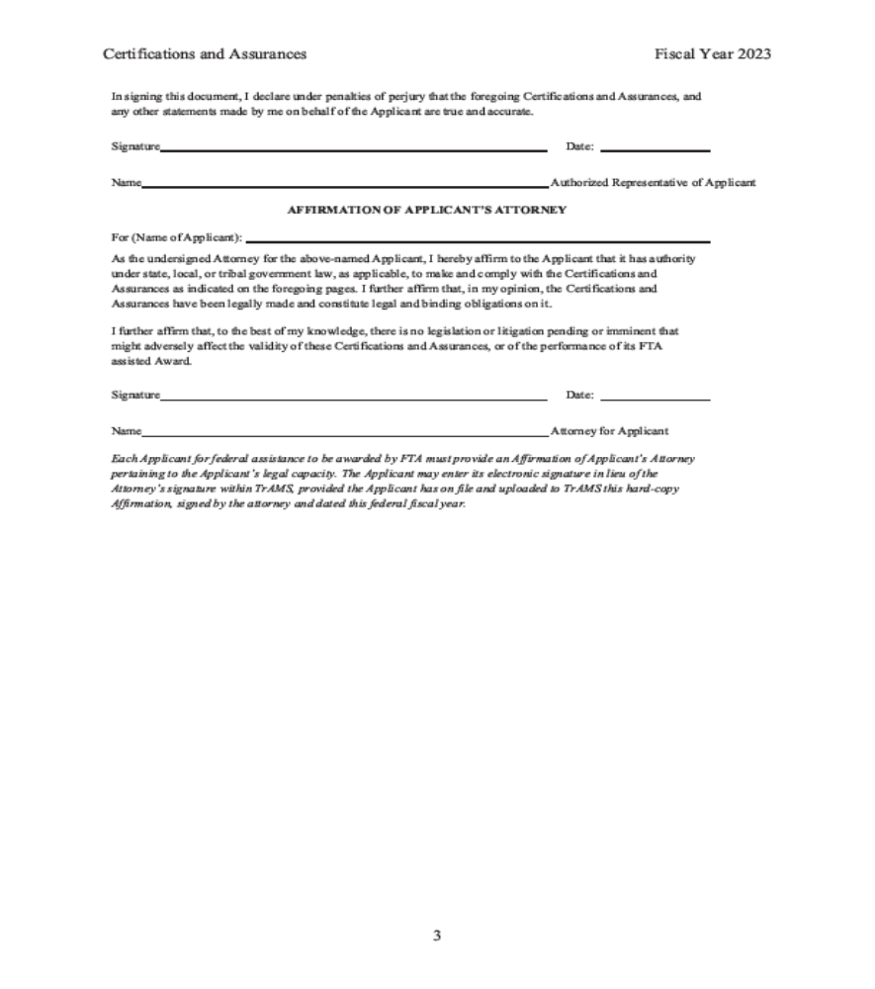

ASSURANCE OF COMPLIANCE WITH SPECIAL 49 U.S.C. 5333(b)

LABOR WARRANTY

(Refer to Pages 25-29 of your Application Procedures Manual for complete information on this warranty.)

The applicant HEREBY AGREES THAT as a condition to receiving federal financial assistance form the Department of Transportation, as authorized under the Non-Urbanized Area Formula Program, Title 49 CFR 5311, it will comply with the terms and conditions of the Special 49 CFR 5333(B) Warranty for Application to the Small Urban and Rural Program.

The applicant FURTHER AGREES THAT it will assume all legal and financial responsibility relative to compliance with the terms and conditions of the Warranty.

SIGNATURE
TITLE
DATE

APPLICANT NAME:

APPENDIX A

SUPPLEMENTAL DOCUMENTATION

COORDINATION OF TRANSPORTATION SERVICES

1. Certified newspaper copy of your public notice (clip notice only).

2. Copies of all responses received.

3. Copies of any coordination agreements

4. Copies of initial letter to the MPO regarding Coordinated Public Transit-Human Services
Transportation Plan and the response letter.

OTHER REQUIRED DOCUMENTATION

- Authorizing resolutions (3 originals)

- 49 U.S.C. 5333(b) Labor Warranty listing of recipients, other public providers and union representation [and additional 5333(b) requirements if applicable]

- Map of current service areas with routes marked

- Fare Schedule

- Service Schedule

- Service Policy

- A description of all components of your substance abuse prevention program

- Drug and Alcohol Part 655 Certification

- Solicitation and Bid proposal of selected contractor

- In-kind documentation

APPLICANT NAME:

49 U.S.C. 5333(b) LABOR WARRANTY LISTING OF RECIPIENTS, ELIGIBLE SURFACE PUBLIC TRANSPORTATION PROVIDERS AND LABOR REPRESENTATION
PAGE |  | OF

RECIPIENT | PROJECT DESCRIPTION | OTHER ELIGIBLE SURFACE TRANSPORTATION PROVIDERS | LABOR ORGANIZATION REPRESENTING EMPLOYEES OF PROVIDERS, IF ANY
Application for Section 5311(f) Intercity Bus Program funds for Operating Assistance for purchase of vehicles for _______________________
to provide intercity bus service in
Louisiana.

